The exceptional students of IIUCNN have secured highly esteemed foreign fellowships for their master's studies.
We are delighted to announce that students from the International & Interuniversity Centre for Nanoscience and Nanotechnology (IIUCNN) have successfully secured coveted fellowships for their Master's research projects at renowned foreign universities.
McGill University, Canada
One outstanding Masters student from IIUCNN's Polymer Science and Engineering has achieved a monthly four-month stipend of 1000 CAD at McGill University in Canada to support their research endeavours.
POLYMAT, Spain
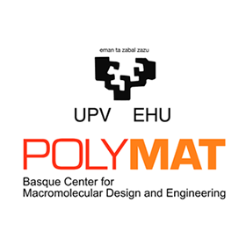
One exceptional Masters student from IIUCNN's Polymer Science and Engineering has achieved a one-year stipend of 900 euros per month at POLYMAT - University of Basque Country in Spain, demonstrating their remarkable dedication to advancing research in the field.
These achievements highlight the excellence and dedication of our students and the strong academic foundation they receive at IIUCNN. We are proud of their accomplishments and look forward to seeing their research contributions positively impact the world of polymer science and engineering.
Congratulations to our talented students, and we wish them every success in their research endeavours abroad!

